JUNIOR AND SENIOR DRAMA
Some activities for you to do at home! It is important to work on our voices, especially when we perform pieces and aren’t wearing microphones!

NUMBER ONE: TONGUE BOOTCAMP
Work on strengthening your tongue muscle! This is an important tool for an actor! Therefore complete a ‘TONGUE BOOTCAMP’.
  - Clean your teeth with your tongue. Create a full circle with your tongue, starting at the back top left, wiping your tongue over the front of your teeth, all the way around to the back top right. Then move down to the back bottom left and wipe all the way around to the back left.
  - Repeat this 8 terms in a circle to the left, then 8 times to the right.
  - Repeat 4 terms to the left, then 4 times to the right
  - Repeat 2 times to the left, then 2 times to the right
  - Repeat once to the left and once to the right
  - IF YOU’VE DONE THIS CORRECTLY YOUR JAW SHOULD REALLY ACHE!
  - Stretch your tongue out by putting the tip of your tongue behind your bottom front teeth and push the rest of your tongue forward. You should feel the stretch! Also massage your cheek bones and neck.
You have successfully removed all tension and should now be able to speak much clearer!

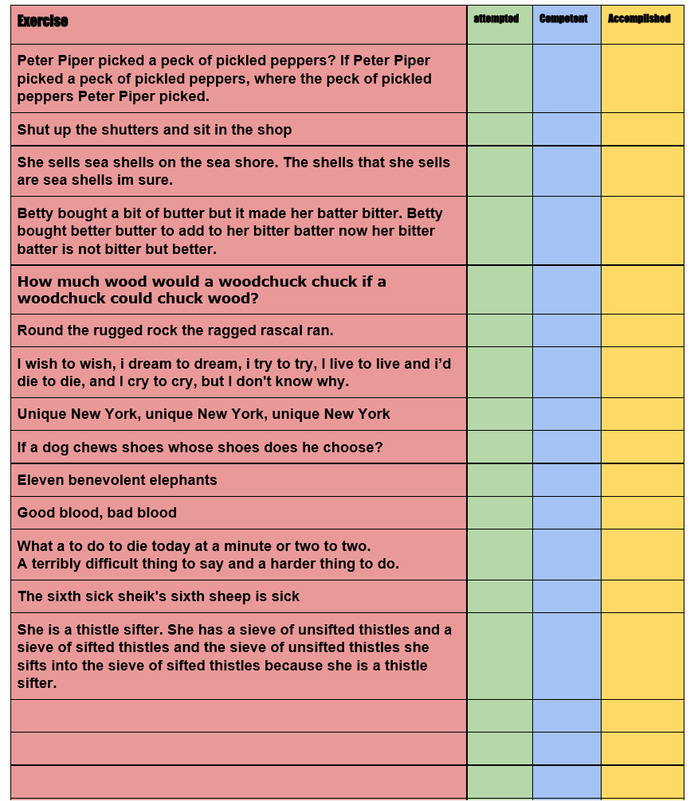
NUMBER TWO: TONGUE TWISTERS
Tongue twisters! This will really help with your articulation. Pick three of the tongue twisters below to work with.
- Say the tongue twister slowly, over pronouncing each letter (spitting the ‘p’, and ‘t’ sounds)
- Slowly speed up, still over pronouncing the letters until you can say it quickly.
- To challenge yourself further, learn the tongue twister off by heart!
This will really help you articulate your words with much more clarity, making it easier for an audience to understand what you are saying from a distance!

NUMBER THREE: BREATHING
Breathing is really important for an actor. Practising your breathing skills can help improve the capacity of air your lungs can hold, which can affect the range, volume and speed of speaking.
- Stand with your feet flat on the floor and keep your shoulders back and relaxed. Alternatively you can lay flat on the floor.
- Place your hands on your stomach
- Breathe in for a count of four and then exhale through your teeth with a ‘sssss’ sound for a count of four. Make sure that your shoulders do not move and that you are using your diaphragm. It should feel like your breathing deep into your belly, rather than your chest.
- Repeat this 4 times.
- Now breathe in for a count of four, and repeat the exhale for a count of eight.
- Repeat this 4 times
- Continue adding an additional 4 seconds to each exhale, taking longer to control your breathe making it last longer. The challenge is to exhale for at least 20 seconds

CREATING A MONOLOGUE FROM A SONG
Reading a song as a monologue.
- Choose one of your favourite musical theatre solo songs
- Write the lyrics onto a plain piece of paper, or print them if you can
- Analyse the lyrics:
  - Who is the singer?
  - Who are you singing to?
  - What is the relationship between you?
  - Where are you?
  - What are you singing about?
  - What is your objective? (Why are you singing the song to this person, what do you want to achieve?)
  - What happens if you don’t achieve the objective?
- Rewrite the lyrics in your own words! I have written an example below using ‘At the end of the day’ from Les Misérables:
LYRICS: At the end of the day you’re another day older
ME: I have a life and a family
LYRICS: And that’s all you can say for the life of the poor
ME: But I have nothing
LYRICS: It’s a struggle, it’s a war
ME: Life is hard , I have to fight
LYRICS: And there’s nothing that anyone’s giving
ME: And nobody gives me anything
LYRICS: One more day standing about, what is it for?
ME: Another day sitting there, what’s the point
LYRICS: One day less to be living
ME: I’d rather die.
- Once you’ve done the above, you should have your own monologue. Practise it, learn it and get ready to perform it!
WRITING YOUR OWN MONOLOGUE/DUOLOGUE
- For 30 minutes sit at your window.
- Write down 10 sounds you hear
- Write down 10 pieces of dialogue you hear (These could be of passers by, or people inside your house!)
- Write down 10 things you see

- Find an image online of a lady/man on the tube/train.
- What do you think they are thinking?
- Write an internal monologue with at least 8 rhetorical questions!
- Your challenge is to make it comical! What problems can they find with the tube?

- You are in Day X or self-isolation
- You can write this from your perspective or you could ask a sibling/parent for their answers
  - What day number of quarantine are you on?
  - What has been their best aspect of self-isolating?
  - What has been their worst aspect of self-isolating?
  - What is something new they have learnt about themselves?
  - Can they recall something funny/angry/annoying?
- Using their answers, write your own comical monologue titled ‘WHAT IT IS LIKE BEING ISOLATED WITH YOUR FAMILY’

Juniors – RESEARCH WW2. We will be writing monologues as wives, soldiers, nurses from WW2 so see if you can find some key facts, or maybe some letters, diary entries online.

Seniors – Continue to explore different ‘British problems’. It might be comical to create a sketch about isolation and staying at home? So far we have considered; over apologising/rudeness, travel, the tube, erratic weather, queuing. Any new ideas and plans will put us in a great position when we are all back together again.

